**Experiment No : 08**

**Title : Develop a user defined Python function to demonstrate the use of**

**parameterized function & value return functions.**

**Problem statements:**

1. Check if number is prime or not.
2. Write a menu driven program, using user defined

functions to find the area of rectangle, square, circle

and triangle by accepting suitable input parameters

from user.

**Theory :**

A function is a block of organized, reusable code that is used to perform a single, related action. Functions provide better modularity for your application and a high degree of code reusing.

Defining a Function:

* Function blocks begin with the keyword **def** followed by the function name and parentheses ( ( ) ).
* Any input parameters or arguments should be placed within these parentheses. You can also define parameters inside these parentheses.
* The first statement of a function can be an optional statement - the documentation string of the function or *docstring*.
* The code block within every function starts with a colon (:) and is indented.
* The statement return [expression] exits a function, optionally passing back an expression to the caller. A return statement with no arguments is the same as return None.

Syntax

def functionname( parameters ):

#code

return [expression]

By default, parameters have a positional behavior and you need to inform them in the same order that they were defined.

**Code :**

**a.code to check whether the number is prime or not**

n=*int*(input('Enter a number : '))

*def* isPrime(*a*):

    if a==1:

        print('1 is neither prime nor a composite number  ')

    elif a > 1:

        for i in range(2,a):

                if (a % i) == 0:

                    print(a," is not a prime number")

                    print(i,"times",a//i,"is",a)

                    break

                else:

                    print(a," is a prime number")

    else:

        print(a," is not a prime number")

isPrime(n)

**output :**

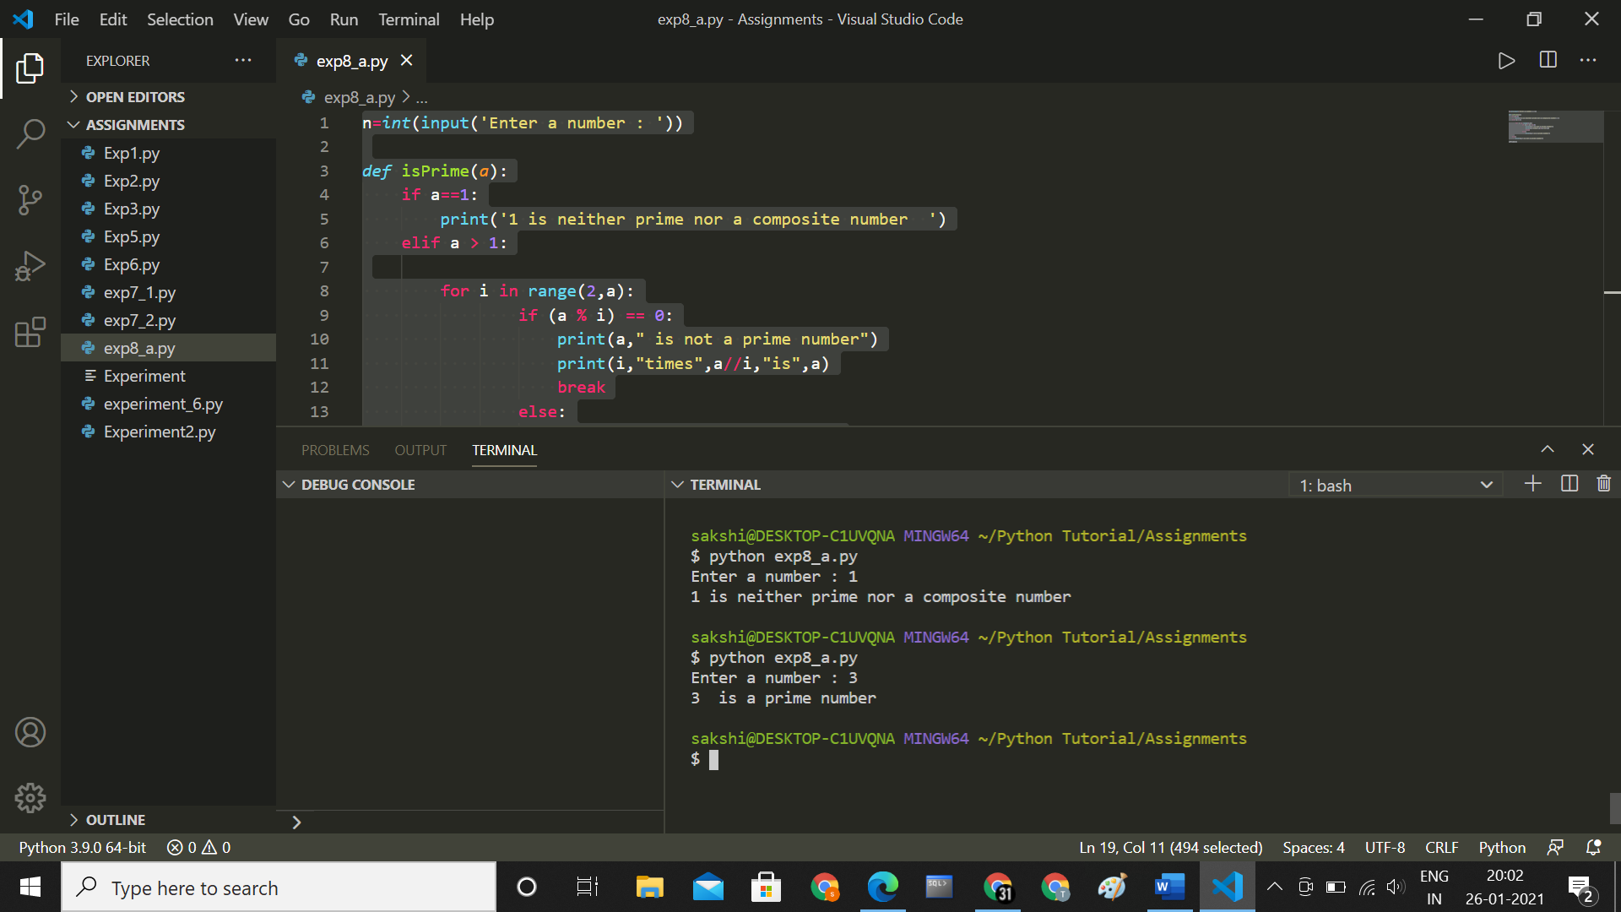

**b.** **Write a menu driven program, using user defined functions to find the area of rectangle, square, circle and triangle by accepting suitable input parameters from user.**

l=*int*(input('enter length of rectangle : '))

b=*int*(input('enter breadth of a rectangle : '))

s=*int*(input('enter side of a square : '))

r=*int*(input('enter radius of a circle : '))

h1=*int*(input('enter base of a triangle : '))

h2=*int*(input('enter height of a triangle : '))

*def* AreaOfRectangle(*l*,*b*):

    return l*b

*def* AreaOfSquare(*s*):

    return s*s

*def* AreaOfCircle(*r*):

    return 3.14*r*r

*def* AreaOfTriangle(*h1*,*h2*):

    return ((1/2)*h1*h2)

print(‘\n’)

print('area of rectangle is ',AreaOfRectangle(l,b),'sq.unit')

print('area of square is ',AreaOfSquare(s),'sq.unit')

print('area of circle is ',AreaOfCircle(r),'sq.unit')

print('area of triangles is ',AreaOfTriangle(h1,h2),'sq.unit')

**output :**

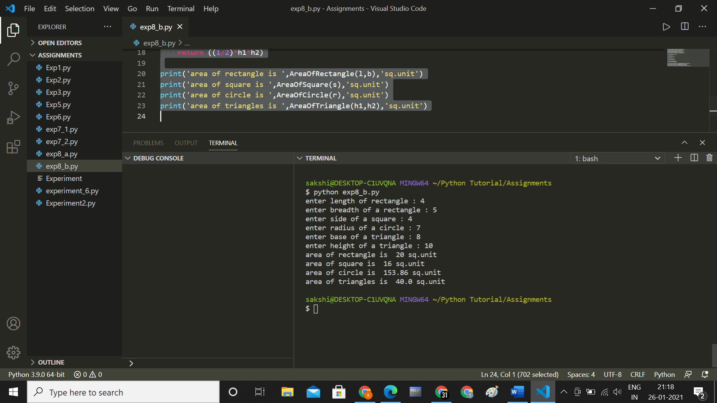

**Conclusion :**

**Thus we have studied and understood Develop a user defined Python function to demonstrate the use of parameterized function & value return functions.**